**Database and Management System Lab**

NAME: PRIYANSHI VARSHNEY

ROLL NO: R2142230042

SAP_ID: 500119947

BATCH 2

B.TECH CSE, SEM-III

**PRESENTED TO**: Dr. Syed Sajid Hussain

# Experiment 16: To understand the concepts of Trigger.

**Objective:** Students will be able to implement the concept of trigger.

1. Using implicit cursor update the salary by an increase of 10% for all the records in EMPLOYEES table, and finally display how many records have been updated. If no records exist display the message “No Change”.

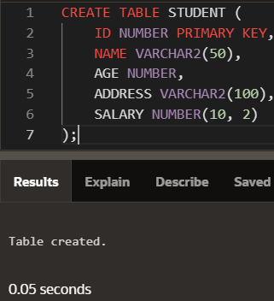Creating STUDENT Table:

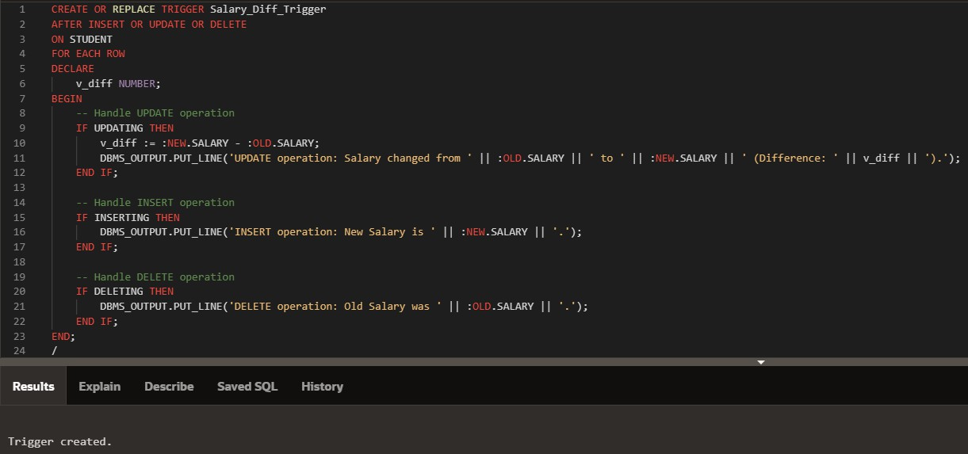INPUT:

OUTPUT:

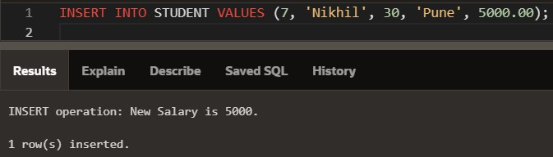Inserting:

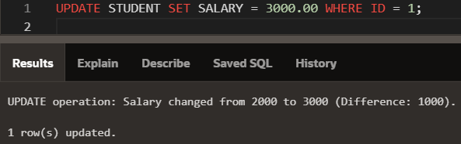Updating:

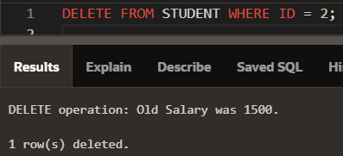Deleting: